Create table with the following fields

1. **tblcourse –** Course_id (PK, AI), Coursename, Courseshortname, Coursetype

2. **tblbatch** **–** Batch_id (PK, AI), Batchname

3. **tblstudent** - Student_id, Student_Name, Student_Email, Student_Gender, Student_DOB, Courseid, Batchid, Student_mark

**1.Select all the details of Course**

SELECT * FROM tblcourse;

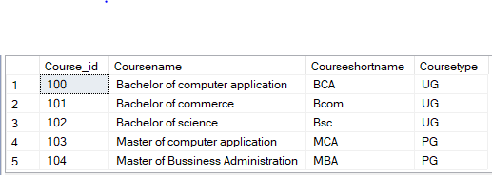

**2.Select the name of UG courses**

SELECT Coursename FROM tblcourse WHERE Coursetype='UG';

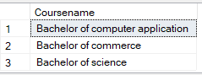

**3. Select the name and short name of PG Courses**

SELECT Coursename, Courseshortname FROM tblcourse WHERE Coursetype='PG';

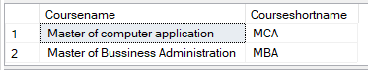

**4. Select the details of batches**

SELECT * FROM tblbatch ;

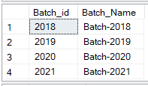

**5. Select the details of students**

SELECT * FROM tblstudent;

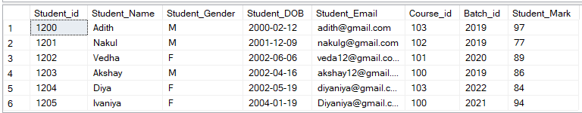

**6. Insert details whose Course is MCA or BCA**

INSERT INTO tblstudent VALUES(1206,'JITHIN','M','1999-06-01','jithin@gmail.com',103,2020,97);

INSERT INTO tblstudent VALUES(1207,'ARYA','F','2002-03-12','arya78@gmail.com',100,2022,90);

INSERT INTO tblstudent VALUES(1208,'NAVYA','F','2002-10-10','navyanavi@gmail.com',100,2022,80);

SELECT * FROM tblstudent WHERE Course_id in (100,103);

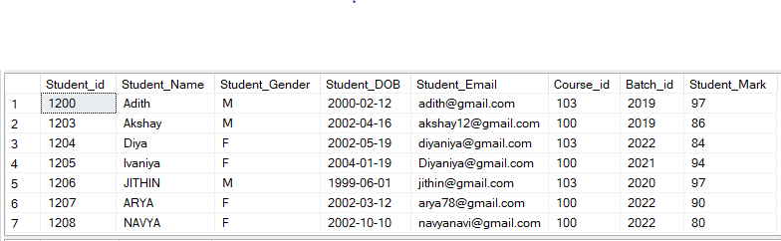

select * from tblstudent;

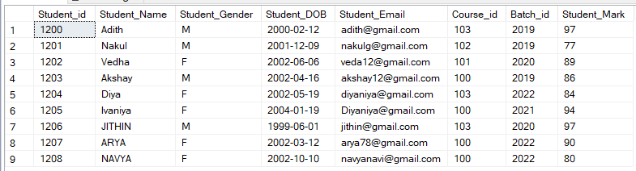

**7. Select the count of male and female student (use if case statement)**

SELECT COUNT(case when Student_Gender='M' then 1 end) AS Total_Male,

COUNT(case when Student_Gender='F' then 1 end)As Total_Female from tblstudent;

